January 1, 2022

Dear Friends,

On the heels of 2020’s challenges, 2021 brought us both amazing progress and frustrating setbacks. The incredible rollout of several effective, FDA approved COVID-19 vaccines helped reduce the risks of this deadly pandemic – but vaccine hesitancy, combined with the dangers of new variants, have prolonged this crisis and created new risks for Maine people. The challenges raised tension levels to boiling points during the fallout of the 2020 presidential election and the January 6th Capitol attack. But despite that, Congress was able to deliver for a nation gripped by an unprecedented pandemic. As we reflect back on the year, we see the important action that will make a difference for Maine people – as well as work still unfinished.

As COVID-19 continued to impact communities across our state and the country, Congress’s first priority this year was to confront the pandemic’s health threats and economic toll. We immediately got to work on the American Rescue Plan, crafting an emergency bill to meet the moment and get our nation back on stable footing. The legislation delivered essential support to businesses facing crises, households in need, and the medical professionals on the front lines of this fight. The funds helped get vaccine shots in arms, while also confronting the damage done to our economy. All told, the American Rescue Plan is bringing billions of dollars to Maine, helping the state continue to push through this crisis and bounce back stronger than ever.

After passing the American Rescue Plan, Congress turned its attention to a longstanding but unfulfilled priority: infrastructure. Through hard work and compromise, both parties came together to pass a bipartisan bill that finally addresses key infrastructure needs. For Maine people, the bill means an estimated $1.5 billion to repair crumbling roads and out-of-date bridges, $390 million to improve access to clean drinking water, and more. I am most excited about the significant funding for broadband – because, as we have seen during the pandemic, broadband is a necessity to succeed in the 21st century economy. The historic investments in the bipartisan infrastructure bill, combined with additional funding I pushed for in the American Rescue Plan, will bring an estimated $400 million for broadband home to Maine. These funds will be nothing short of transformational, creating new opportunities across our state.

These two bills have made and will continue to make a real difference for Maine people, helping to both address the challenges of COVID-19 and lay a foundation for long-term success. I am proud of what we’ve accomplished this year – but I know there is still a lot of work to do and that the road ahead is challenging. Even still, I am filled with optimism because I know the true nature of our citizens, though challenged, has not changed. Despite every hardship, people in towns and communities have stepped up with strong local leadership, a willingness to help, and a Maine ‘neighborhood’ spirit. It is why I truly believe we can and will get through anything together. Mary and I wish you a happy, healthy, and safe 2022.
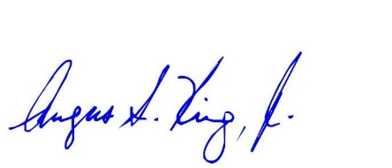
Best Regards,

Angus S. King, Jr.
United States Senator

